**ONLINE MOBILE RECHARGE SYSTEM**

**Angular**  **Project**

**[ANGULAR 10 /ASP.NET WEB API /**

**MS SQL SERVER]**

**Submitted By:**

**Naveeth Z A**

**Rajagurunathan Manikandan**

**Saravanakumar Balasubramaniyam**



October - 2020

**PROJECT DESCRIPTION**

**Project Title :** Online Mobile Recharge System

**Abstract :** This System provides recharge of many mobile companies as well as all kind of recharge are possible. This System will provide facility for customer to recharge mobile at anytime from anywhere. This System keeps the history of the past recharges. The user has to register himself.

**Type of Project:** Web API Application

**Technology :** Angular 10, ASP.Net – Web API.

**Database :** MS SQL-Server

**Web Application Name**:

**PAY**



***A Payments App built for India, by Indians***

**DESCRIPTION:**

The proposed project for recharging mobiles online is a web application developed to automate the mobile recharging process. It roots out the manual card system of recharge and introduces a new and genuine online recharge process. It can be used by costumer of any telecommunication company from anywhere.

The online mobile recharge system is beneficial to both the admins and users. Using the online application, the admin can add new tariff plans and update or modify the existing tariff plans. It helps the users in creating their account, and then recharging the mobiles phones at any time.

**OBJECTIVE:**

Online Mobile Recharge is a web-based application developed in ASP.NET to recharge mobile phones. The project focuses at providing an easy and reliable platform to recharge mobile of any telecommunication company through online without buying recharge card. The registered users of the system can recharge their prepaid mobile phones from anywhere at any time. The proposed project for recharging mobiles developed to automate the mobile recharging process. It roots out the manual card system of recharge and introduces a new and genuine online recharge process. The online mobile recharge system is beneficial to both the admins and users. Using the online application, the admin can add new operators, tariff plans, offers and update or modify the existing tariff plans. It helps the users in creating their account, and then recharging the mobiles phones at any time.

**PROJECT DEMO:**

**Type of Users:**

1. User

**Project Flow:**

* **User Functionalities:**

1. User Home: User can able to view different sections such as features, about us of Rpay.
2. All Plans: User can able to view recharge tariff plans for all operators with different plan types, validity and price.
3. Airtel Plans: User can able to view the mobile recharge plans made available by Airtel. We have also added filters by which the users can view the plans details based on the plan type (Popular Plans, Top-Up, 4G Data Voucher, International Roaming)
4. BSNL Plans: User can able to view the mobile recharge plans made available by BSNL. We have also added filters by which the users can view the plans details based on the plan type (Popular Plans, Top-Up, 4G Data Voucher, International Roaming)
5. Jio Plans: User can able to view the mobile recharge plans made available by Jio. We have also added filters by which the users can view the plans details based on the plan type (Popular Plans, Top-Up, 4G Data Voucher, International Roaming)
6. VodafoneI Plans: User can able to view the mobile recharge plans made available by VodafoneI. We have also added filters by which the users can view the plans details based on the plan type (Popular Plans, Top-Up, 4G Data Voucher, International Roaming)

**DATABASE DESIGN**

**Entity Relationship Diagram:**

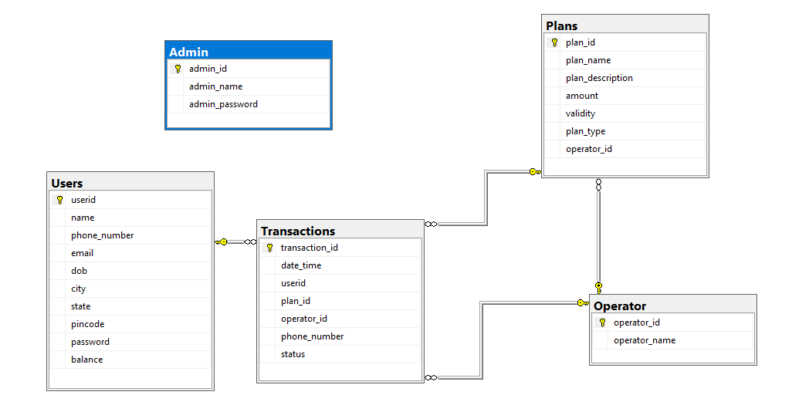

**Table Schema Diagram:**

**TABLE 1: Users**

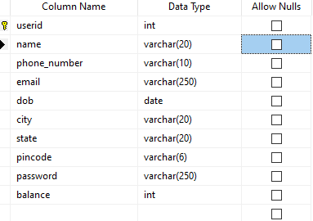

**TABLE 2: Admin**

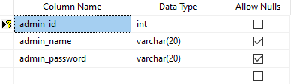

**TABLE3: Operators**

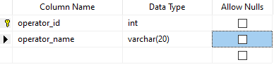

**TABLE4: Plans**

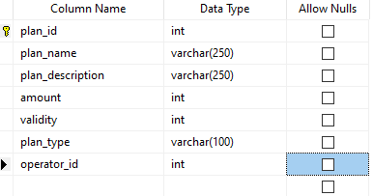

**TABLE5: Transactions**

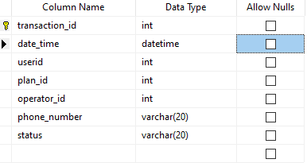

**SOURCE CODE**

**Web API Service call:**

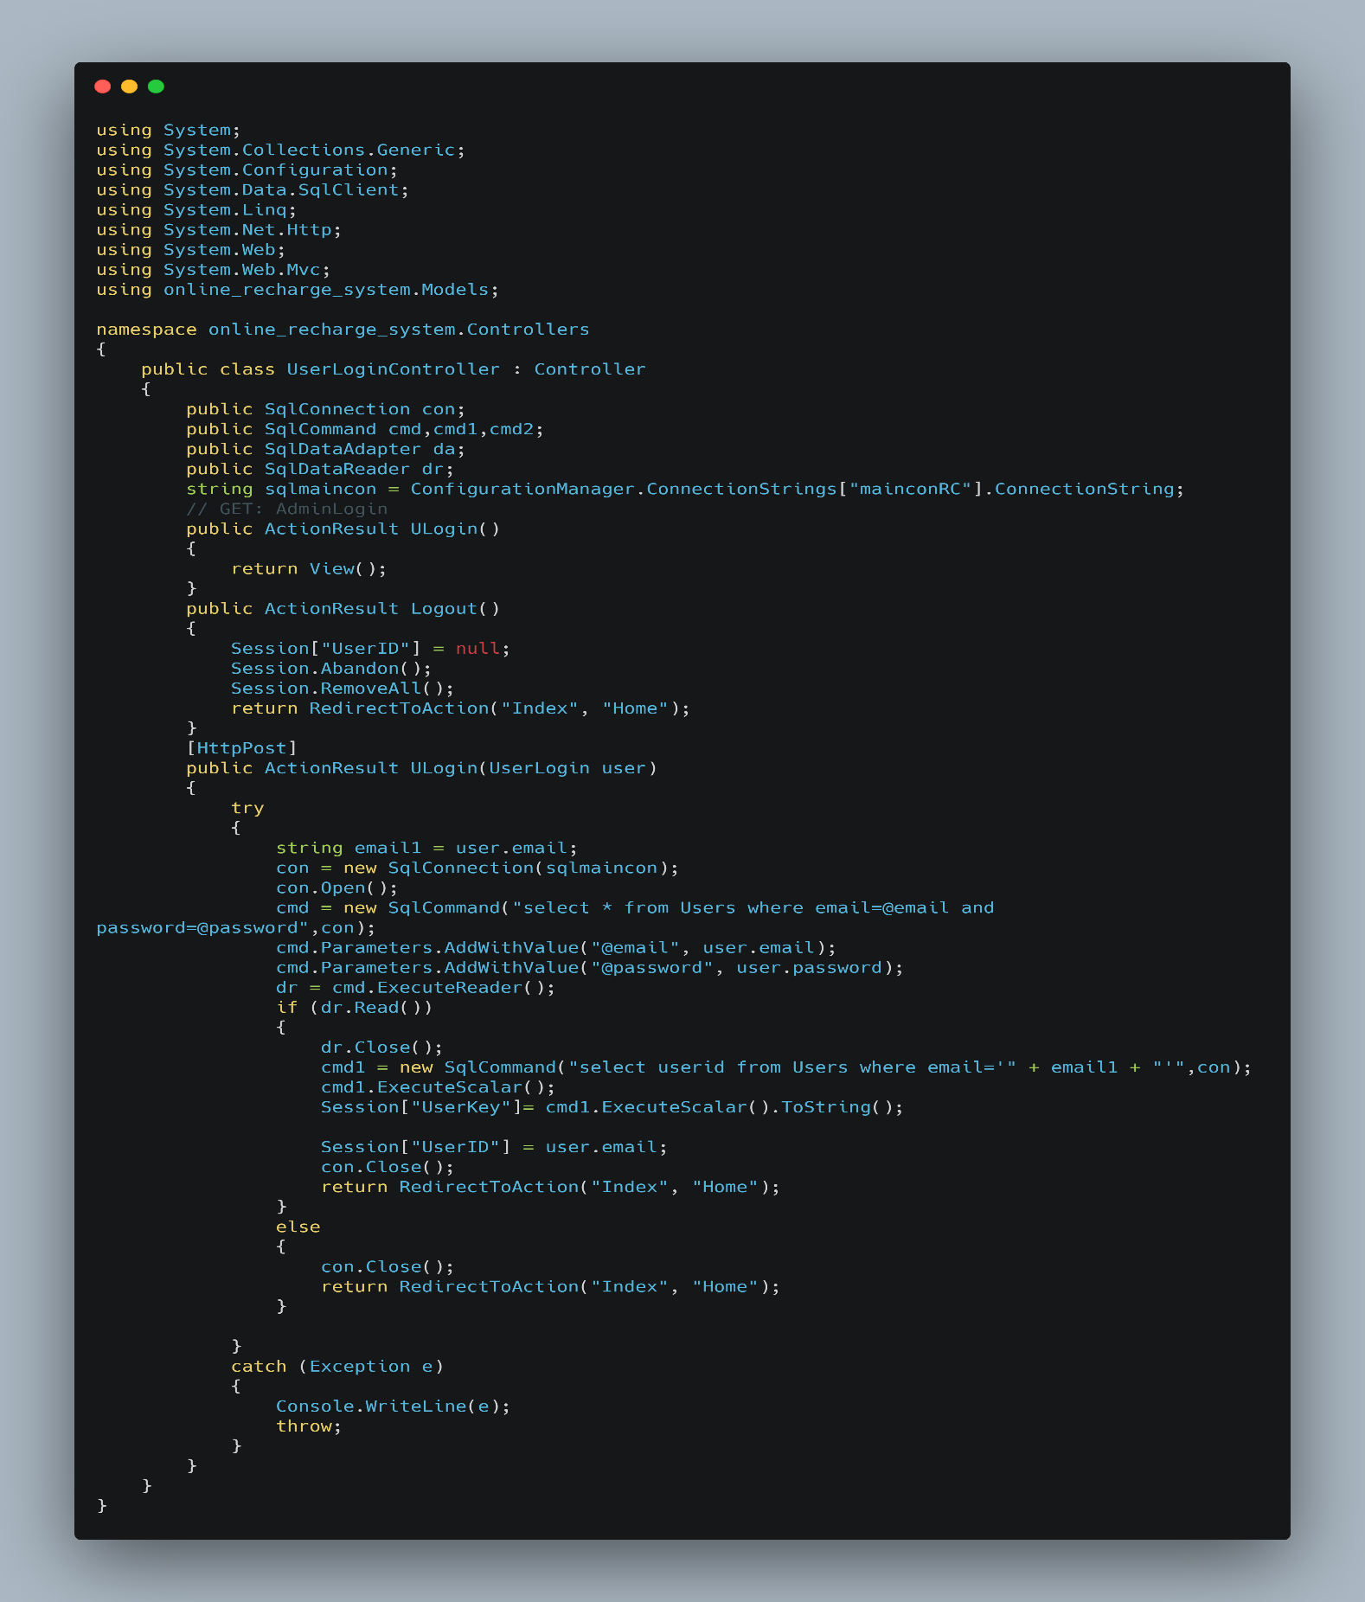

**User Home:**

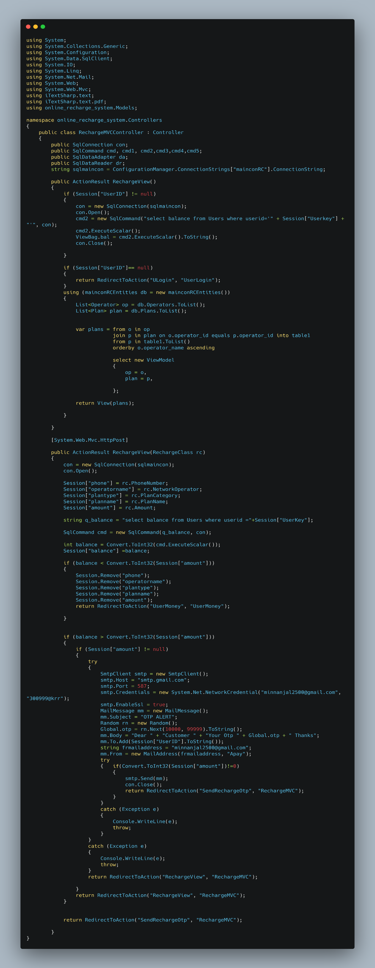

**Airtel Plans:**

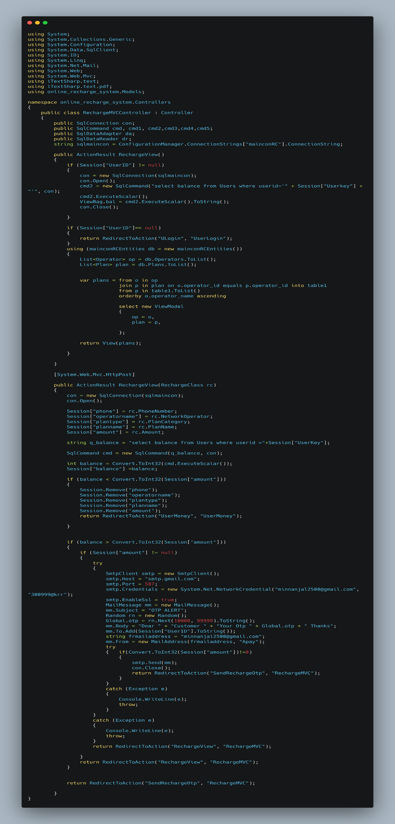

**BSNL Plans:**

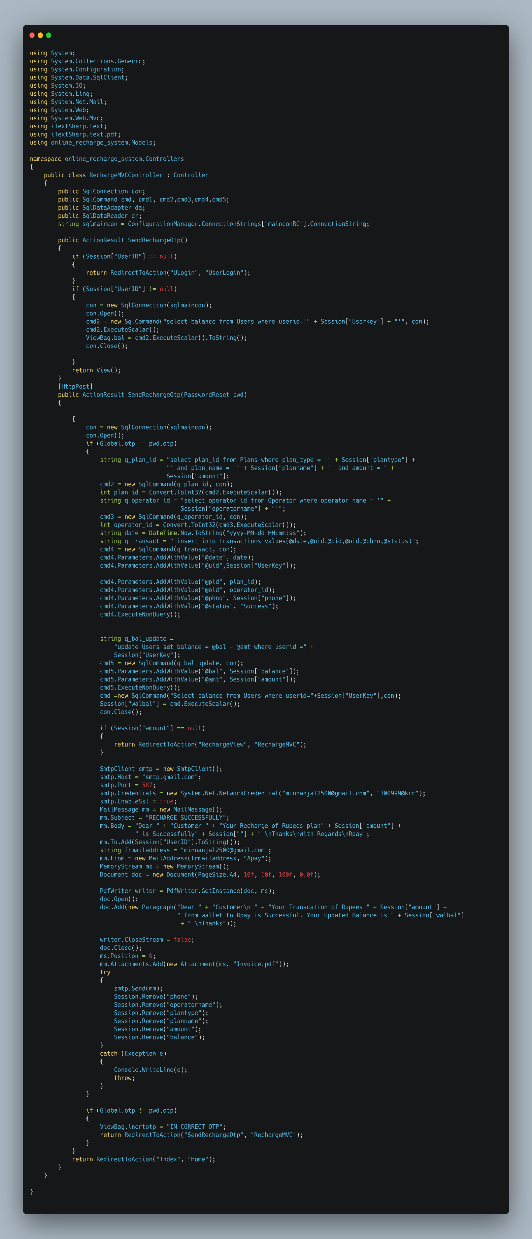

**Jio Plans:**

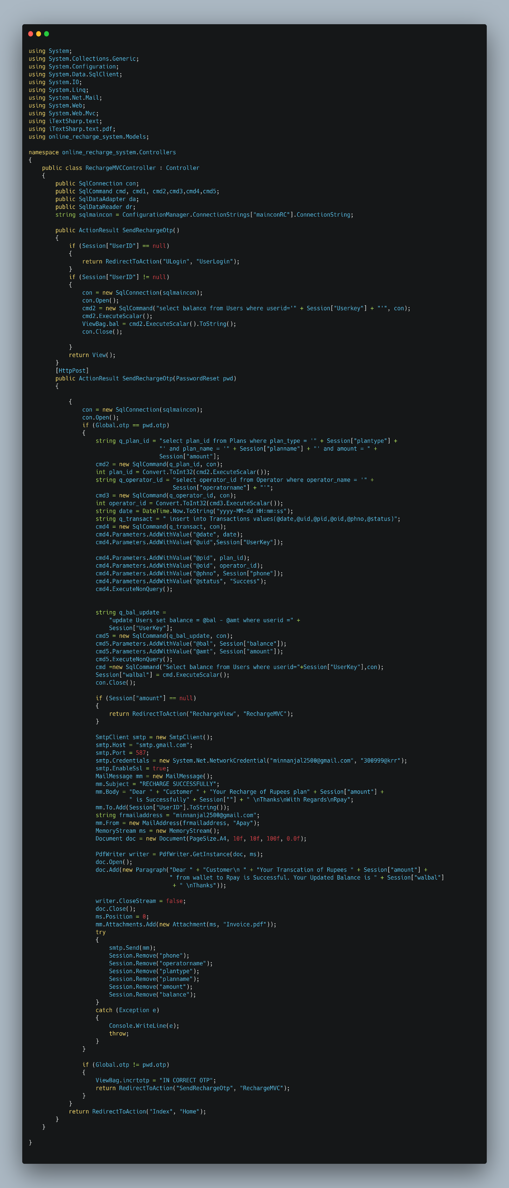

**VodafoneI Plans:**

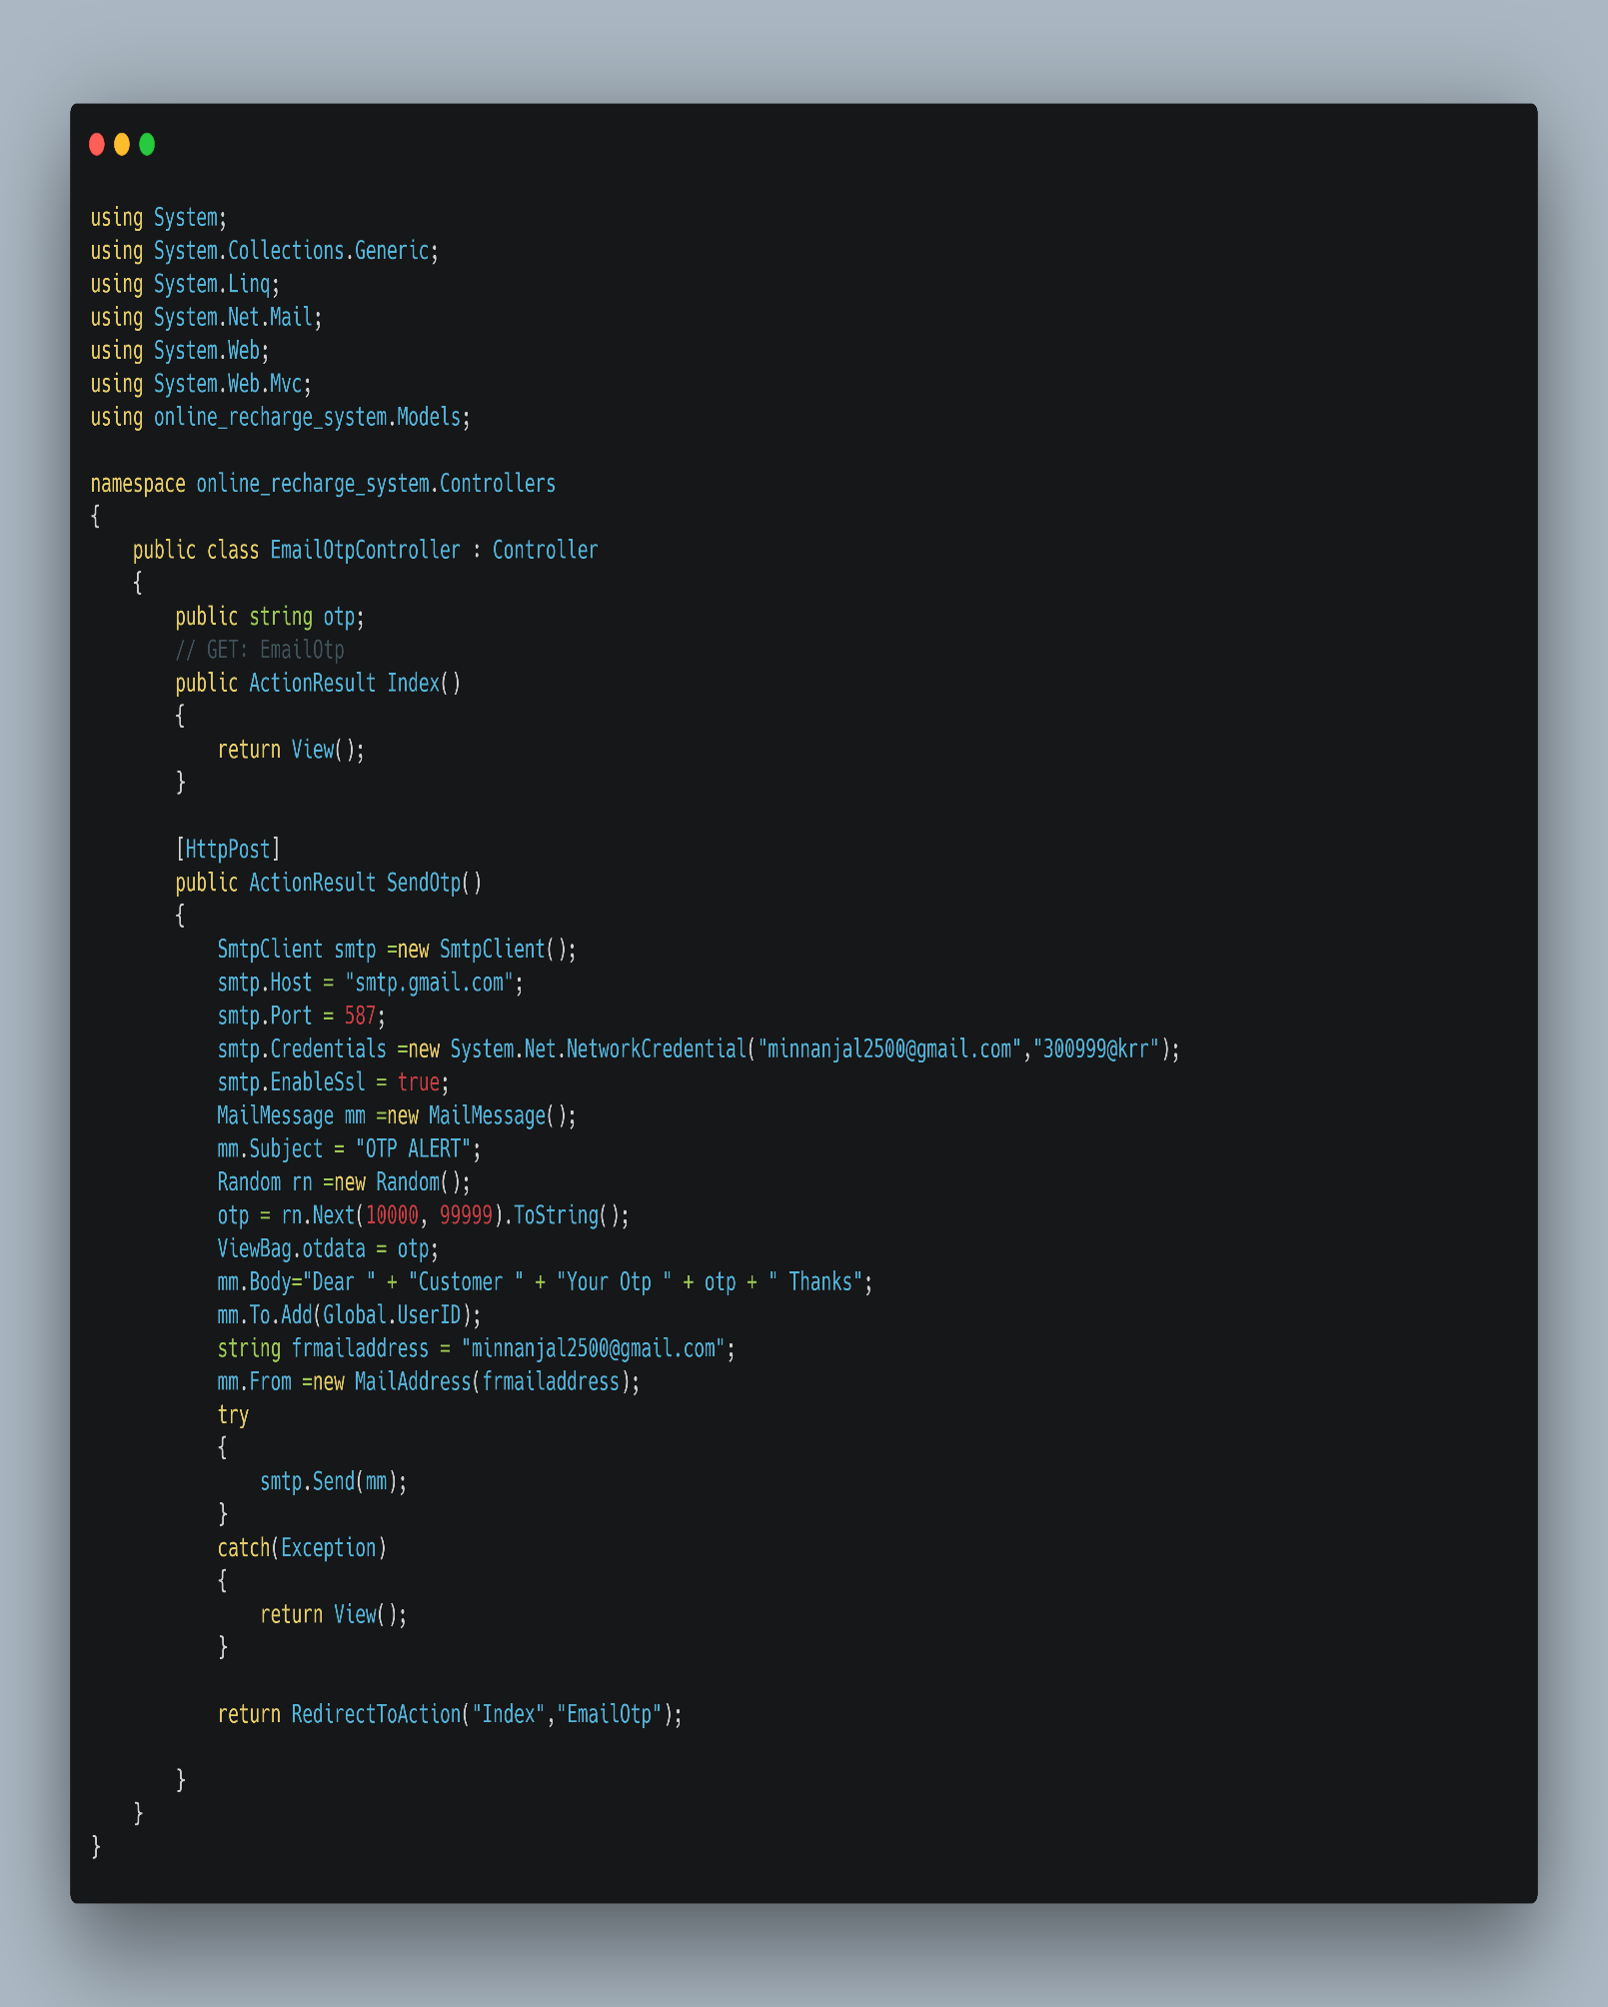

**Add Money to Wallet:**

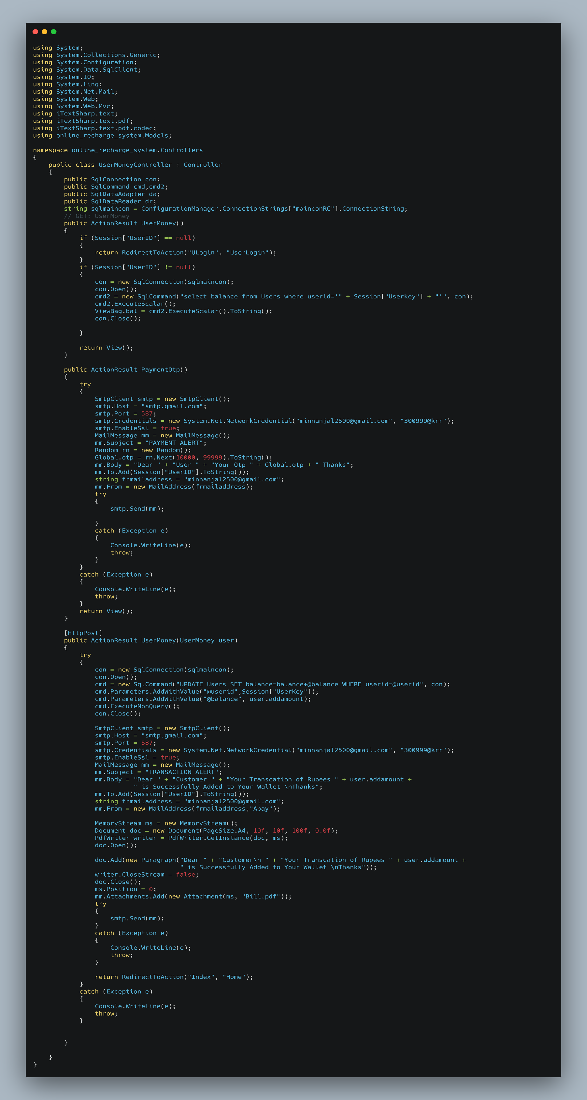

**Add money to Wallet: contd**

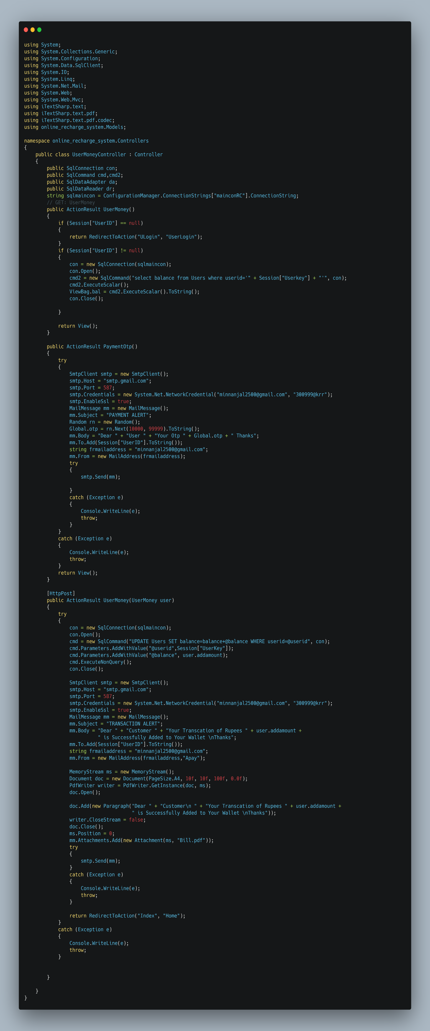

**My Plans:**

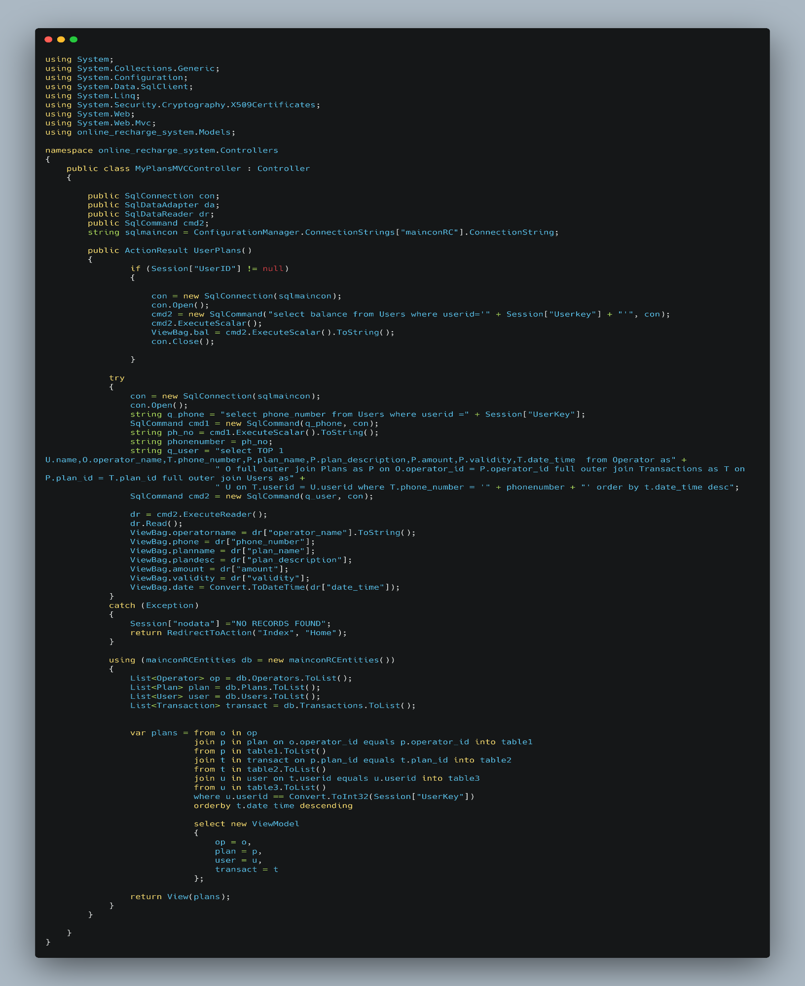

**PROJECT OUTPUT SCREENSHOTS**

**SCREENSHOT 1.1:** Home

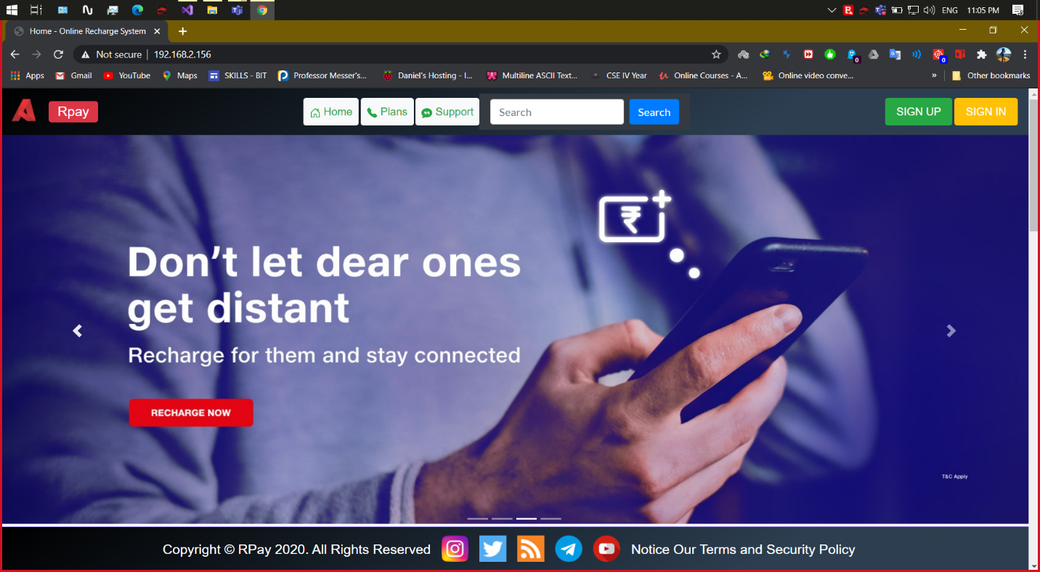

**SCREENSHOT 1.2:** Home (Our Network Partners)

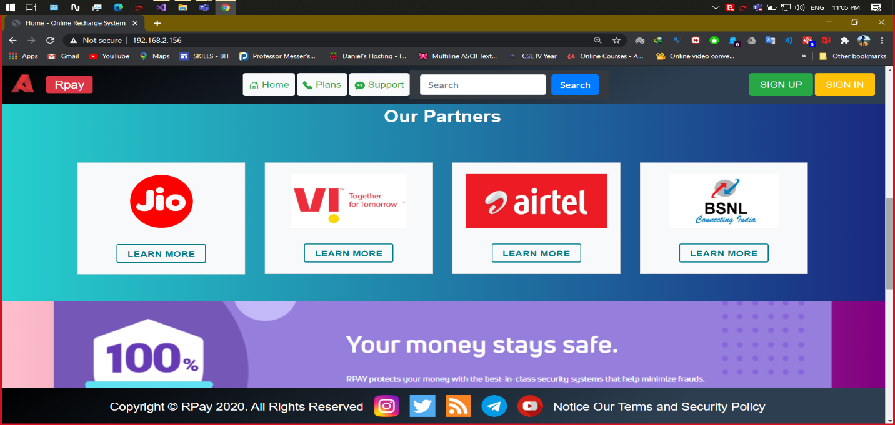

**SCREENSHOT 1.3:** Home (Our Team)

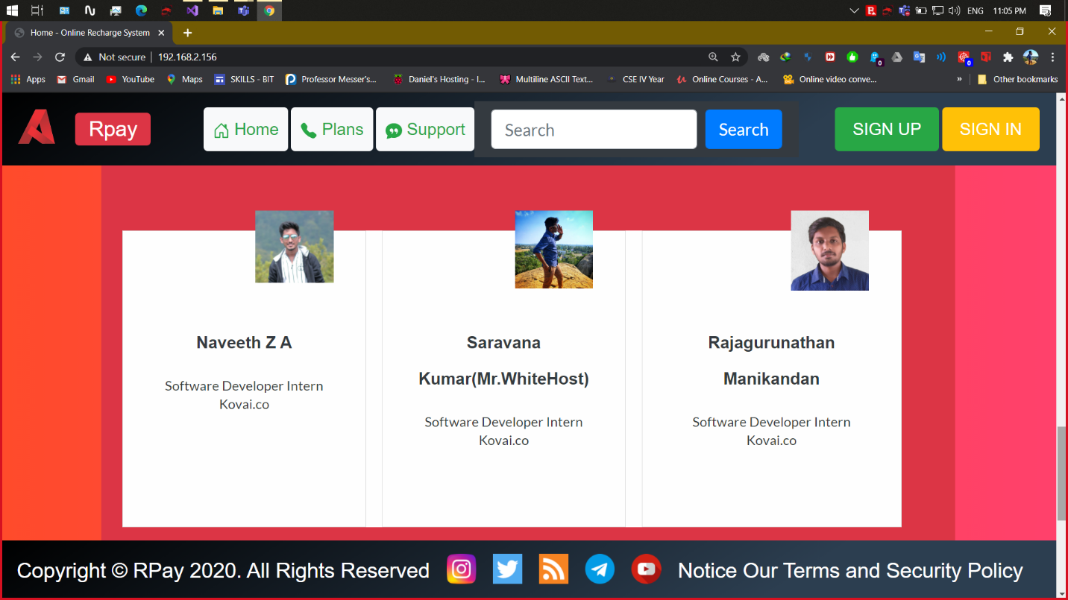

**SCREENSHOT 1.4:** Home (Recharge Plans)

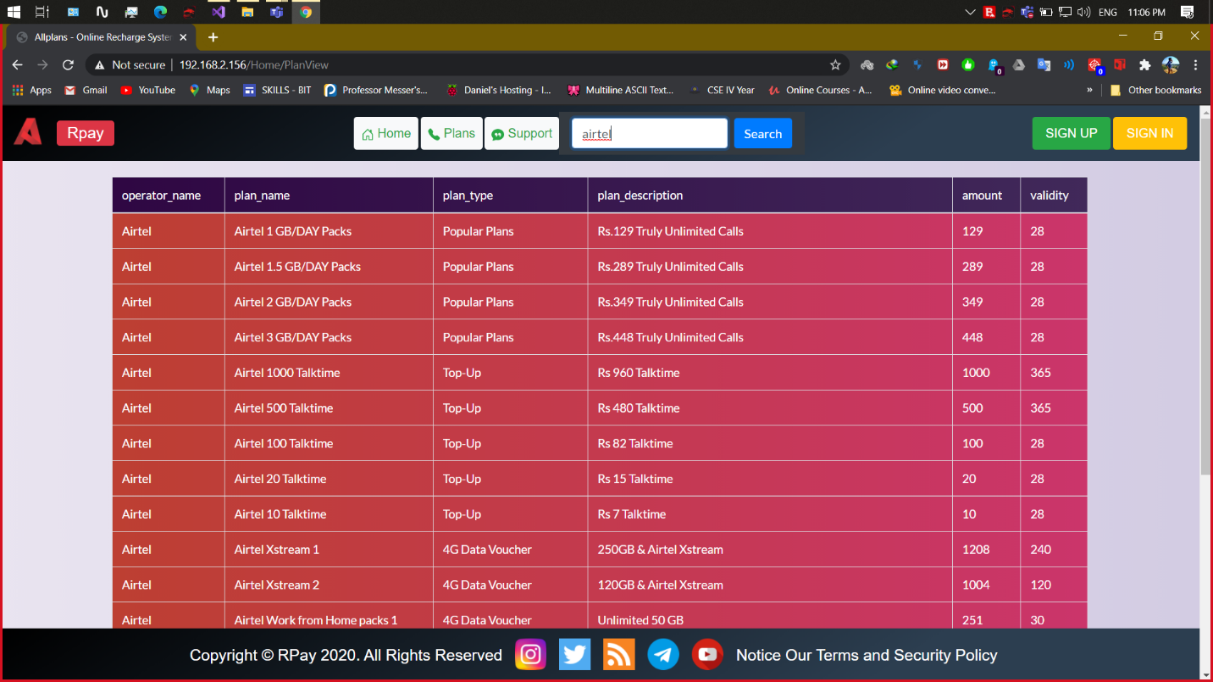

**SCREENSHOT 2.1:** Airtel Plans

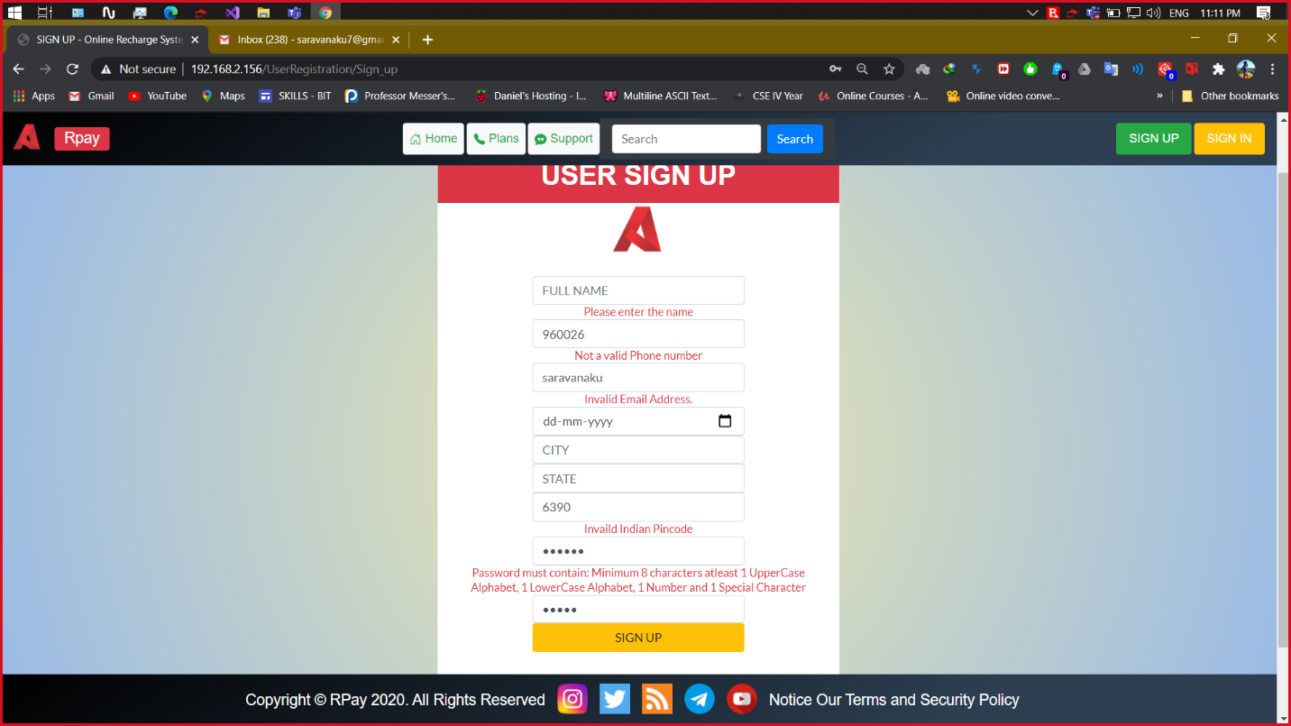

**SCREENSHOT 2.2:** Airtel Plans (Popular Plans)

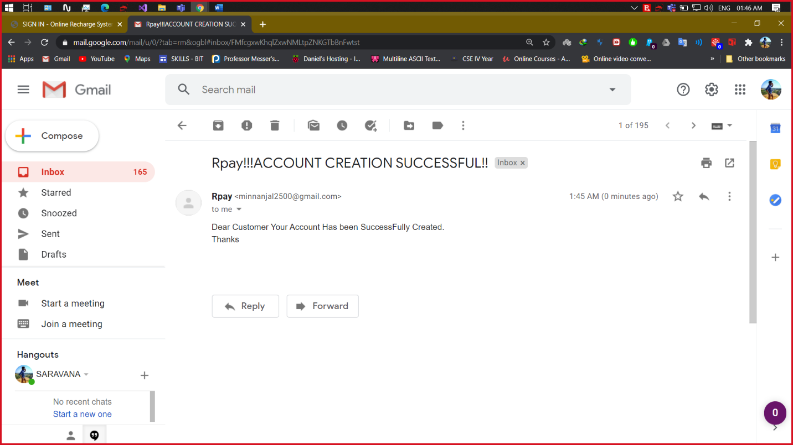

**SCREENSHOT 2.3:** Airtel Plans (Talk Time Plans)

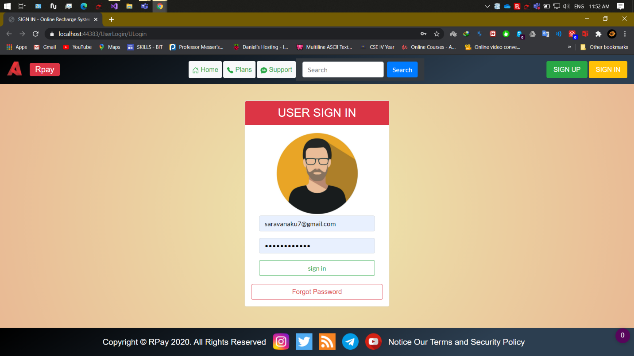

**SCREENSHOT 2.4:** Airtel Plans (4G Data Voucher Plans)

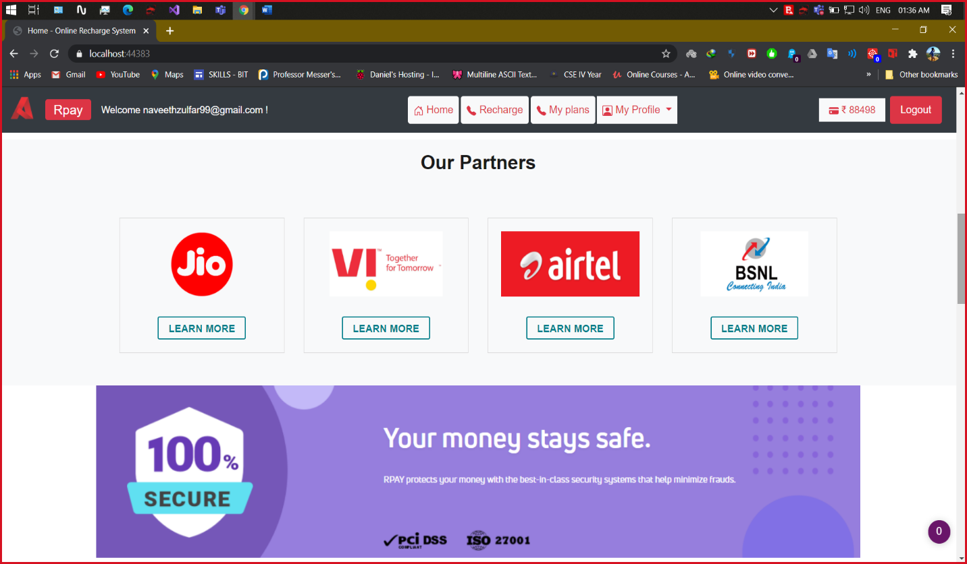

**SCREENSHOT 2.5:** Airtel Plans (International Roaming Plans)

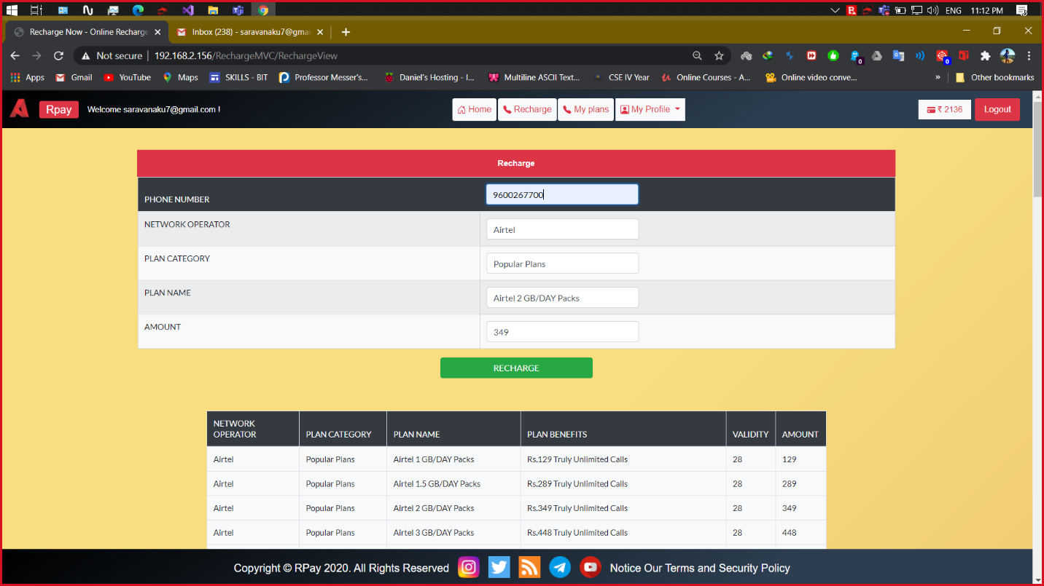

**SCREENSHOT 3.1:** Jio Plans

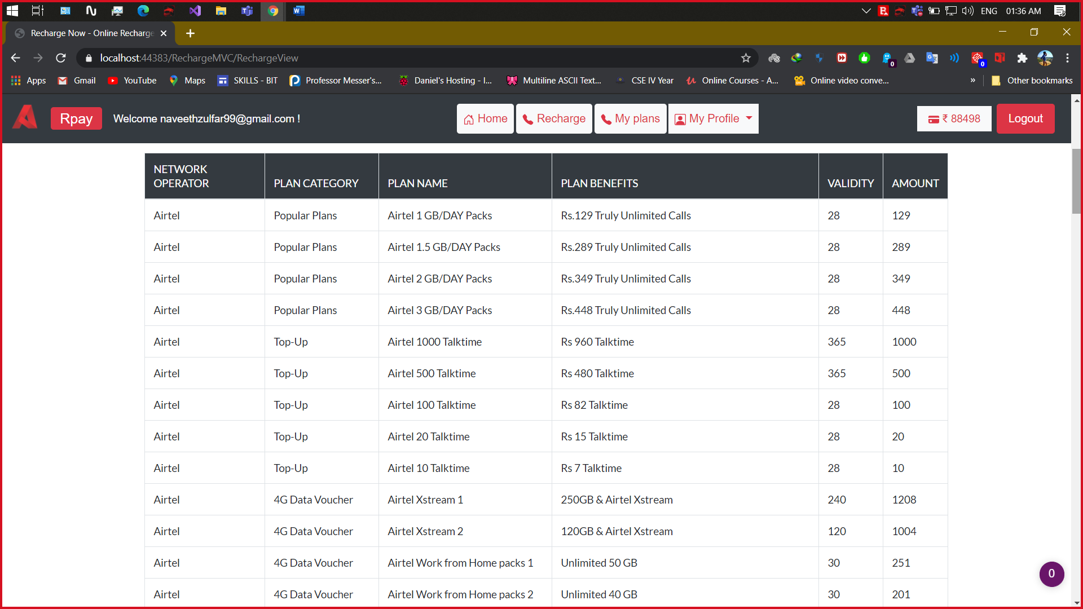

**SCREENSHOT 3.2:** Jio Plans (Popular Plans)

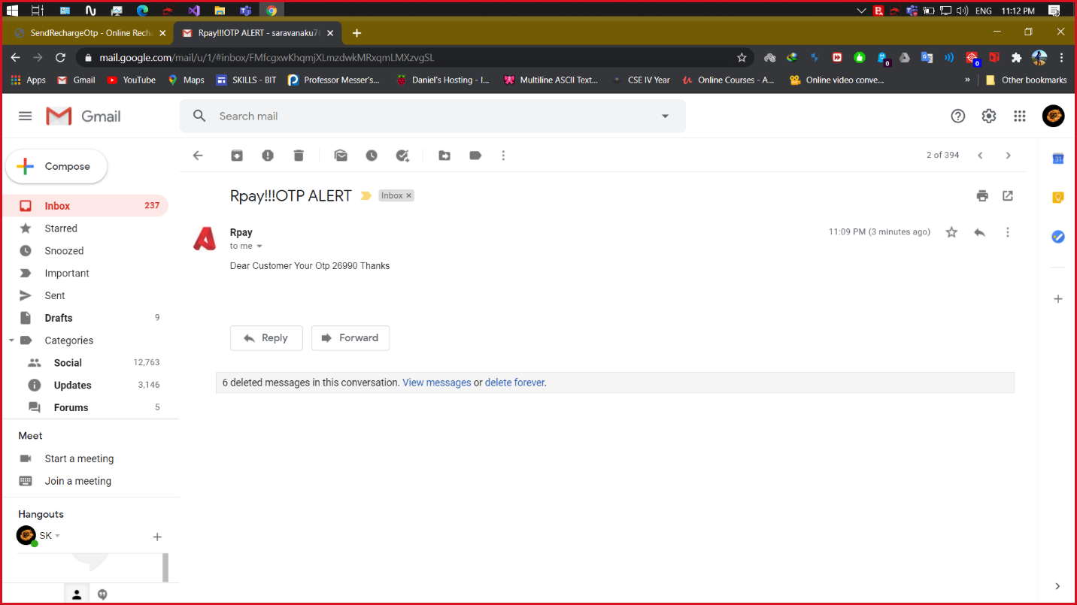

**SCREENSHOT 3.3:** Jio Plans (Talk Time Plans)

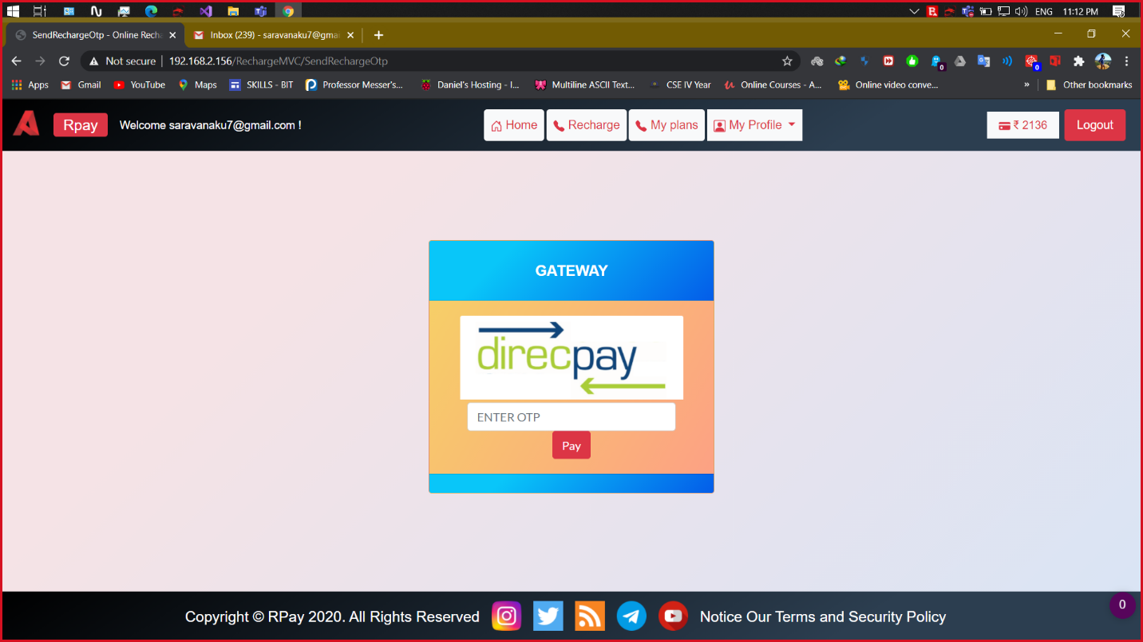

**SCREENSHOT 3.4:** Jio Plans (4G Data Voucher Plans)

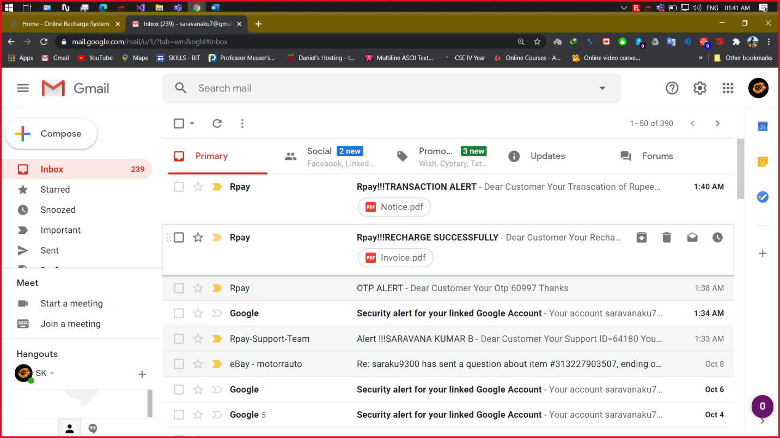

**SCREENSHOT 3.5:** Jio Plans (International Roaming Plans)

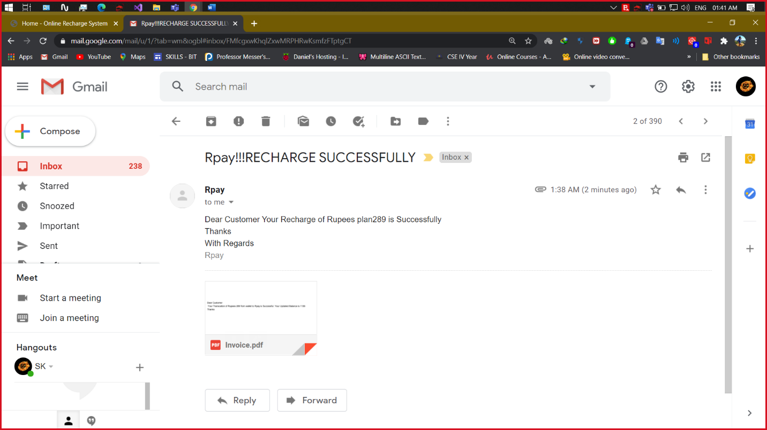

**SCREENSHOT 4.1:** BSNL Plans

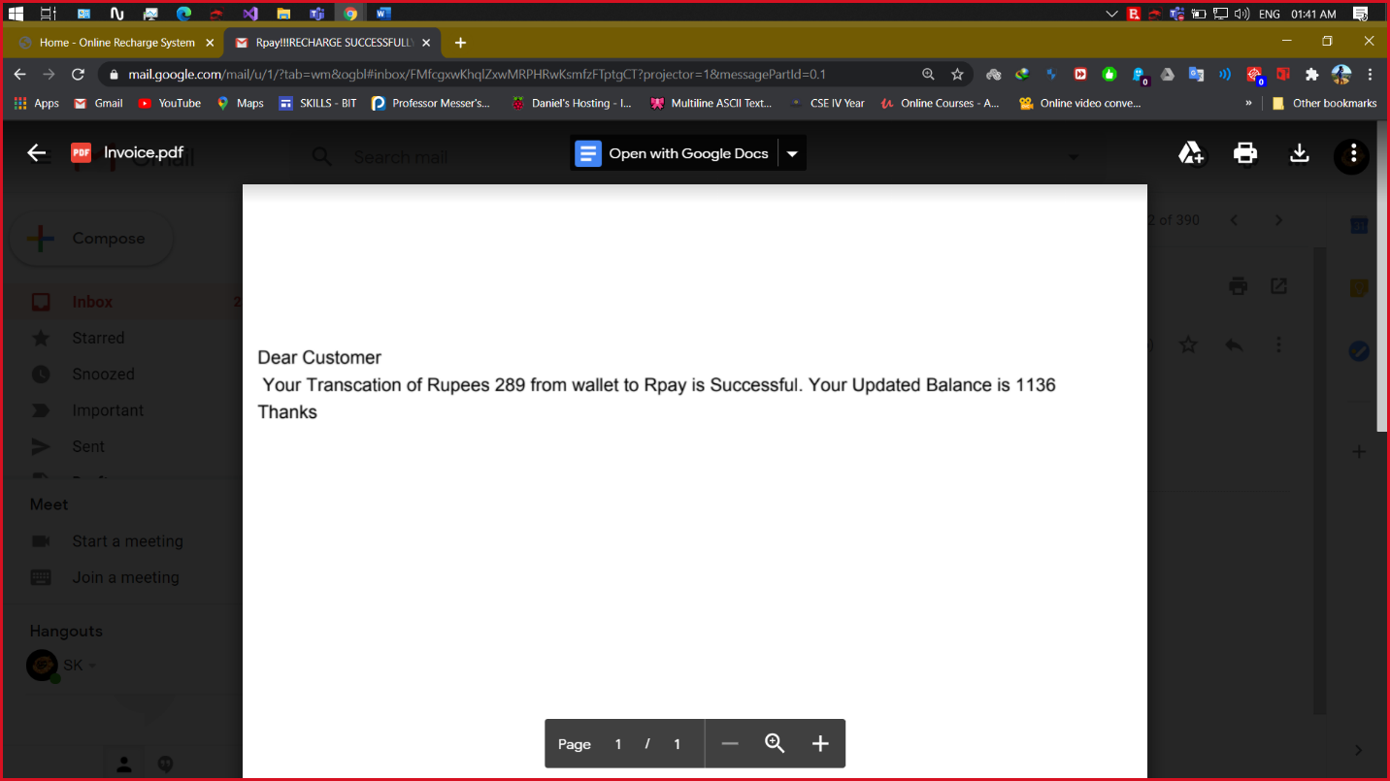

**SCREENSHOT 4.2:** BSNL Plans (Popular Plans)

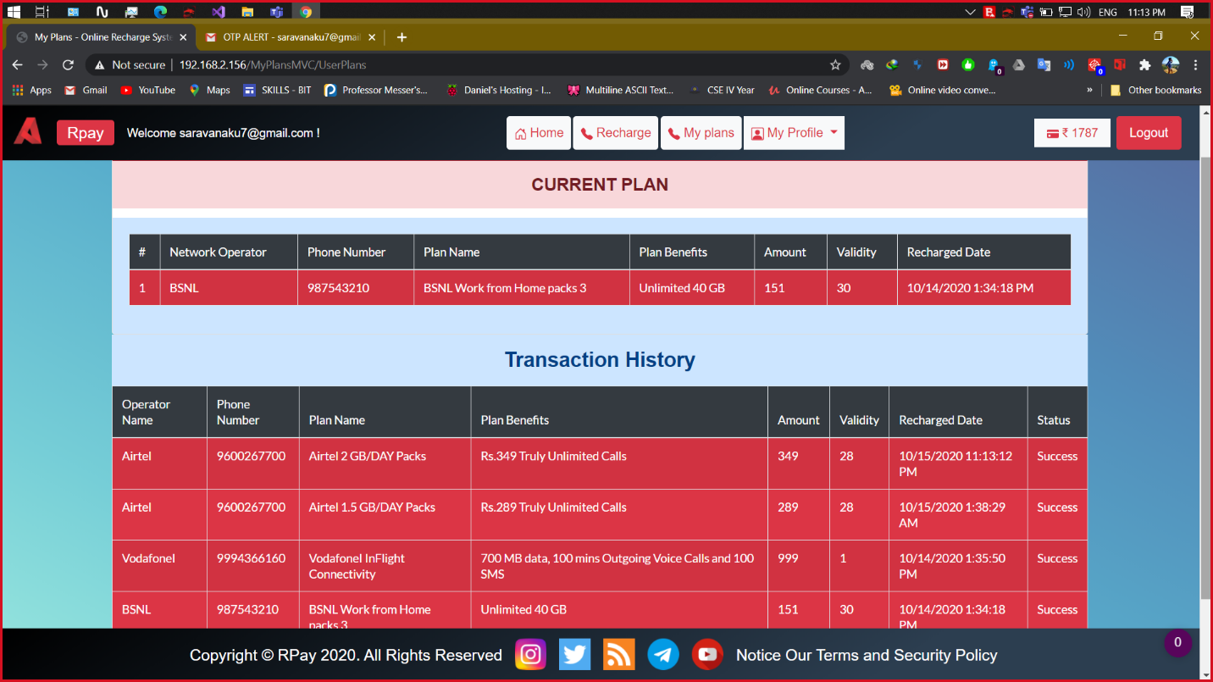

**SCREENSHOT 4.3:** BSNL Plans (Talk Time Plans)

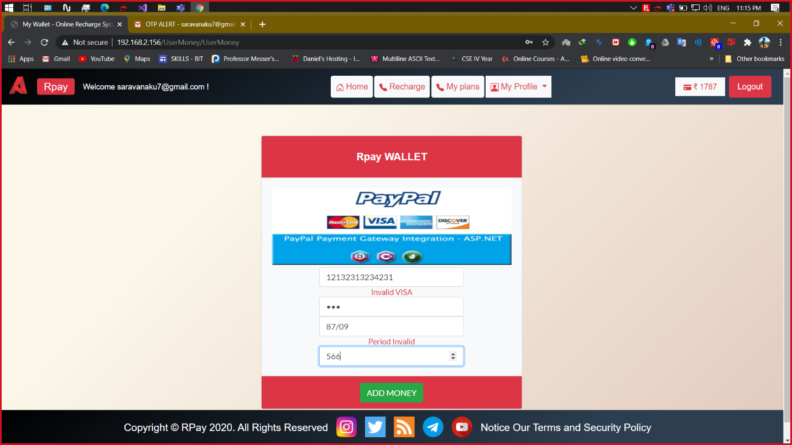

**SCREENSHOT 4.4:** BSNL Plans (4G Data Plans)

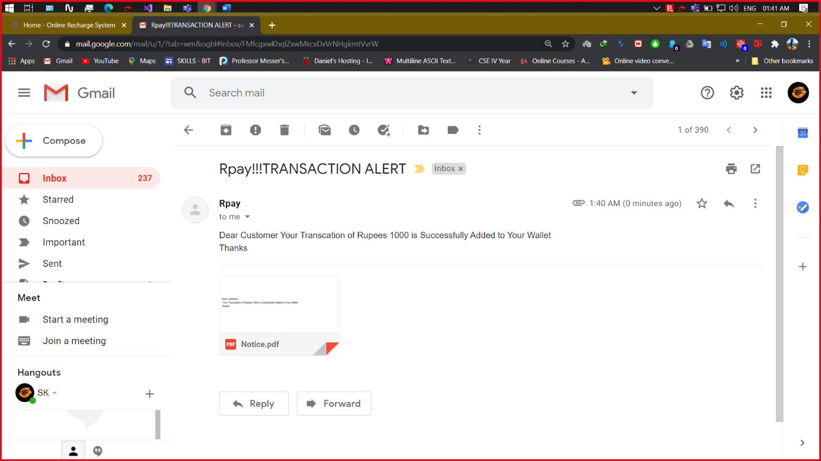

**SCREENSHOT 4.5:** BSNL Plans (International Roaming Plans)

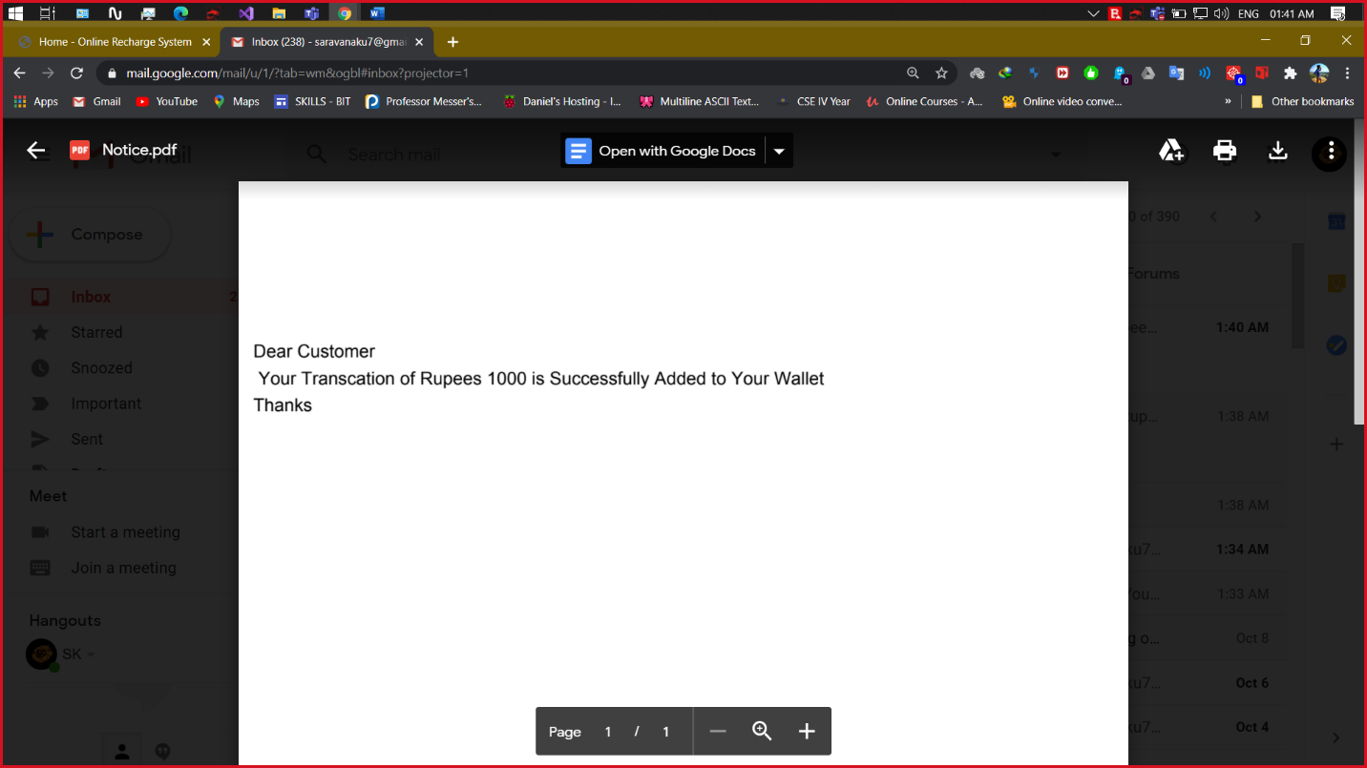

**SCREENSHOT 5.1:** VodafoneI Plans

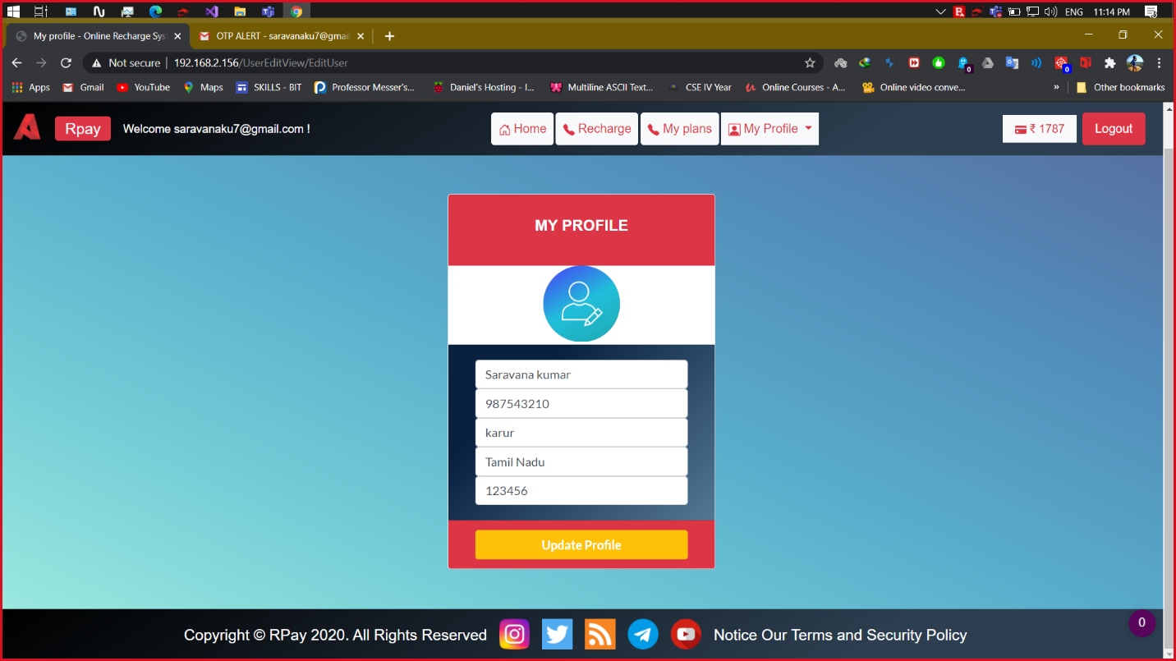

**SCREENSHOT 5.2:** VodafoneI Plans (Popular Plans)

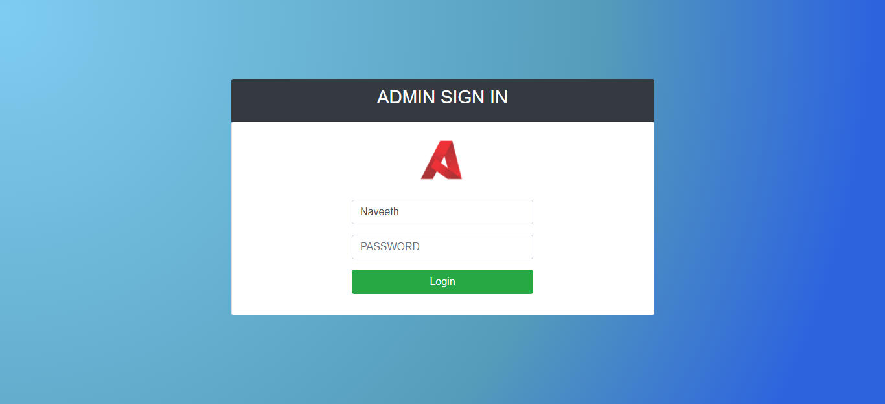

**SCREENSHOT 5.3:** VodafoneI Plans (Talk Time Plans)

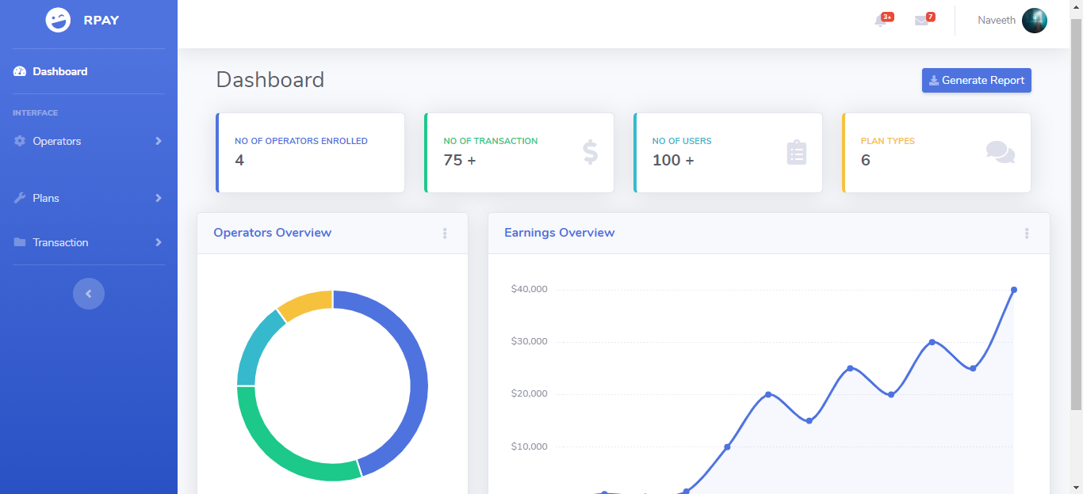

**SCREENSHOT 5.4:** VodafoneI Plans (4G Data Voucher Plans)

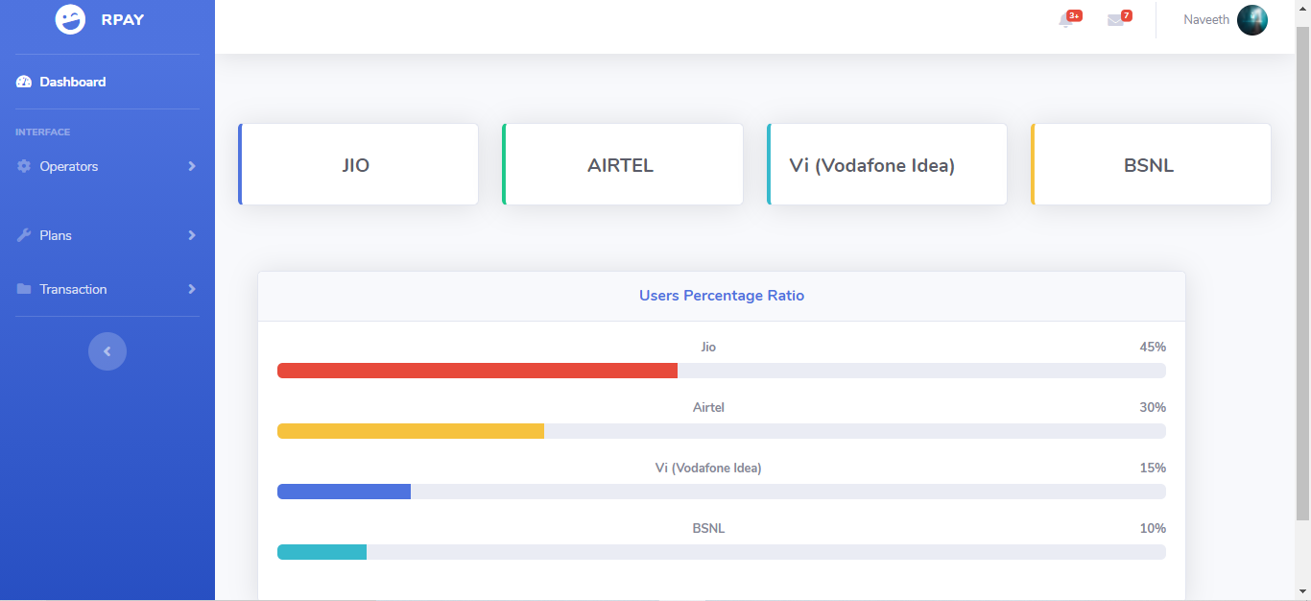

**SCREENSHOT 5.5:** VodafoneI Plans (International Roaming Plans)

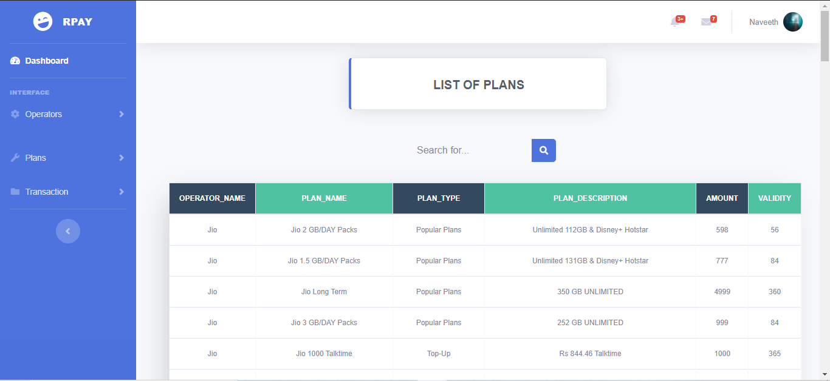

**ROLES AND RESPONSIBILITIES**

**SCREENSHOT WISE:**

|  |  |  |  |
| --- | --- | --- | --- |
| **Screenshot No** | **Page Name** | **Frontend** | **Backend** |
| 1 | Home | Naveeth, Saravanakumar | Saravanakumar |
| 2.1 | Airtel Plans | Naveeth, Saravanakumar | Saravanakumar |
| 2.2 | Airtel Plans  (Popular Plans) | Saravanakumar | Rajagurunathan,  Saravanakumar |
| 2.3 | Airtel Plans  (Talk Time Plans) | Naveeth, Saravanakumar | Saravanakumar |
| 2.4 | Airtel Plans  (4G Data Voucher Plans) | Rajagurunathan | Rajagurunathan, Saravanakumar |
| 2.5 | Airtel Plans  (International Roaming Plans) | Rajagurunathan | Rajagurunathan |
| 3.1 | Jio Plans | Saravanakumar | Saravanakumar |
| 3.2 | Jio Plans  (Popular Plans) | Rajagurunathan | Rajagurunathan |
| 3.3 | Jio Plans  (Talk Time Plans) | Rajagurunathan | Rajagurunathan |
| 3.4 | Jio Plans  (4G Data Voucher Plans) | Naveeth | Naveeth |
| 3.5 | Jio Plans  (International Roaming Plans) | Naveeth | Naveeth |
| 4.1 | BSNL Plans | Naveeth | Naveeth |
| 4.2 | BSNL Plans  (Popular Plans) | Rajagurunathan | Naveeth |
| 4.3 | BSNL Plans  (Talk Time Plans) | Rajagurunathan | Saravanakumar |
| 4.4 | BSNL Plans  (4G Data Voucher Plans) | Saravanakumar | Saravanakumar |
| 4.5 | BSNL Plans  (International Roaming Plans) |  |  |
| 5.1 | VodafoneI Plans |  |  |
| 5.2 | VodafoneI Plans  (Popular Plans) |  |  |
| 5.3 | VodafoneI Plans  (Talk Time Plans) |  |  |
| 5.4 | VodafoneI Plans  (4G Data Voucher Plans) |  |  |
| 5.5 | VodafoneI Plans  (International Roaming Plans) |  |  |
|  | Database Management | Rajagurunathan | |

**MODULE WISE:**

**1) Member Name: Naveeth Z A (Team Leader)**

* Home - Front End
* User Signup - Front End
* User Home - Front End
* Admin Login - Front End & Back End
* Student Profile - Front End & Back End
* Admin Dashboard - Front End & Back End
* Network Operator Manager- Front End & Back End
* Recharge Plans Manager - Front End & Back End
* Recharge Transactions Manager - Back End
* Integration

**2) Member Name: Rajagurunathan Manikandan**

* Database Creation & Management
* Query Management
* My Plans – Front End & Back End
* Recharge - Front End & Back End
* Edit Profile – Front End & Back End
* User Login – Back End
* Customer Support – Front End
* Admin Login - Front End & Back End
* Recharge Transaction Manager – Front End
* Integration
* Dry Run

**3) Member Name: Saravanakumar Balasubramaniyam**

* Home – Front End & Back End
* User Signup– Front End & Back End
* User Login – Front End & Back End
* User Home– Front End &Back End
* Recharge – Back End (Email API Authentication -SMTP)
* Add Money to Wallet- Front End & Back End
* Customer Support – Back End
* Forgot Password - Front End &Back End
* Integration
* Session Management
* Online Database Hosting
* Web Hosting

**PROJECT SOURCE CODE LINK**

**Onedrive:**

[**https://kovailtd-my.sharepoint.com/:f:/g/personal/syed_haroon_kovai_co/ElYOyjneyfNKu3-4wZGwAwUBInH8YMoGF1Me1nmHRXTLOg?e=hlid6n**](https://kovailtd-my.sharepoint.com/:f:/g/personal/syed_haroon_kovai_co/ElYOyjneyfNKu3-4wZGwAwUBInH8YMoGF1Me1nmHRXTLOg?e=hlid6n)